**NAME:** Enahoro Nkemchor Thomas

**STUDENT ID:** THO22568958

**DATE OF LAST UPDATE:** 25th April 2023

# **REFLECTIVE REPORT**

I have just completed the design and development of a responsive Wildlife Resort Website. The purpose of the website is to provide a platform for intended users to be able to book a tour of the resort and view more information about the resort as well as to understand the services offered by the resort.

The website is also intended to raise awareness of the resort through proper SEO and generate Advert revenue for the company.

Intended users of the website are people familiar with wildlife or fascinated about wildlife. Its also for nature lovers. People who search about wildlife resorts or weekend getaways or fun activities on their browsers are also more likely to come across this website on their search results.

**PERSONA:**

All rights reserved


IMAGE SOURCE : GOOGLE

Anabel is a London based entrepreneur who is fascinated about nature and wildlife. On her free time, she likes to travel and explore new places. Her search history mostly entails “things to do in London” “where to get the best wildlife experience” “wildlife resorts”. The website has been designed to tailor her needs through the following:

Strong SEO: The website link will pop up on her search results so it will be easy for her to engage the website and then proceed to browse through the website to understand the resort and make bookings/reservations.

Wildlife information: Anabel is interested in observing wildlife, especially Elephants. The website has information about the types of wildlife that can be seen at the resort, their habitats, and their behaviors.

Accommodations: The website has detailed information about the resort's accommodations, including room types, sizes, and amenities.

Activities: Anabel is interested in Elephant rides and other nature-based activities. list of activities offered by the resort are found on the website.

**WIREFRAME:**

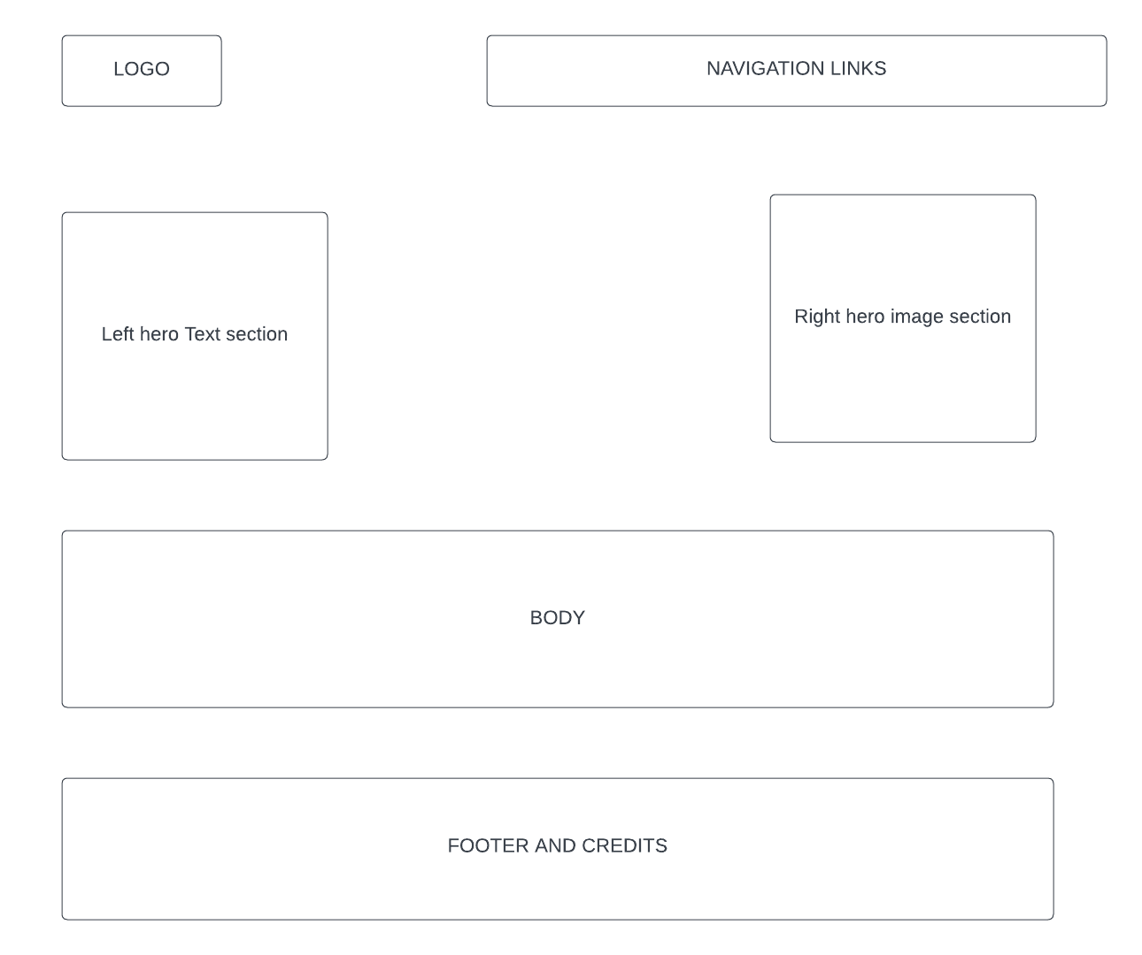

To inform the design of my website, I conducted user interviews with my classmates to understand their needs whilst scrolling through the website.

If I were to put the website live, I would use a reliable web hosting platform. To get the best web hosting platform, I usually look out for the hosting services top companies use for their websites and implement on my own website. Its important to source for a good web hosting company to get the best services and to ensure your website is always accessible online. It’s also necessary to choose a provider with robust security features, such as firewalls, malware scanning, and SSL certificates, to protect the website from attacks.

For the Search Engine Optimization (SEO), I will properly optimize page elements such as titles, headings, p tags and meta descriptions with targeted keywords. I already used a few meta keywords on the website so the website is ready for SEO integration. The first step I always take to integrate websites for SEO is to add the website manually to google search console using google webmaster tool.

After the website is added to google search console, google crawls the website within a few days and render page insights including but not limited to page performance, indexed pages, page/site clicks, fetched data, keywords performance, etc. In addition to other SEO settings and configurations I will create sponsored google ads to make sure my website rank way higher than other websites that offer similar services to mine.

Also, for the analytics, I intend to use Google analytics to get valuable insights from the website.

# **DETAILED REFELECTION**

In this reflective report, I will discuss my learning experience in this module based on my prior knowledge, the main skills I learned, what I found easy and difficult, what I learned about mastering new skills, and how I plan to use it in the future. I’d also write about what I enjoyed throughout the entire website design process.

**Prior Knowledge:**

Before starting this module, I had some prior knowledge of frontend and backend development and have totally chosen web development as my career path. However, whilst working on some website projects, I had always relied on pre-made templates or worked collaboratively with other developers. Throughout this module, I was able to apply the foundational knowledge I had and build upon it to create my Wildlife Resort website from scratch through various resources available online. I’ve referenced the resources I used on the last page.

**Main Skills Learned:**

throughout the course of this module, I can boldly attest that I learned a variety of new skills that have greatly improved my ability to design and develop websites. Some of the main skills I learned include:

User-centered Design Principles: I learned the importance of understanding user’s needs and building a website that excellently meets those needs. This involved creating personas, conducting user interviews, and using card sorting and top task analysis to inform my design choice decisions.

Responsive Design: I learned how to create websites that are responsive to different screen sizes and devices. This involved using CSS frameworks such as Flexbox and Grid, using the media screen query in the CSS as well as designing with a mobile-first approach.

Web Design Aesthetics: I learned about different web design aesthetics which includes Skeumorphism, Neumorphism, Glassmorphism and a whole lot more.

Search Engine Optimization (SEO): I learned how to optimize my website for search engines, including using meta tags, labeling images using alt tag, influence of h1, h2, h3, h4 tags on SEO, etc.

Web Hosting: Understanding the right web hosting choice is a critical factor in any web project. This module has guided my web hosting choices.

JavaScript types, functions and their use and implementation. (VanillaJS and P5): This module has fully introduced me to the world of JavaScript. I have gained more experience on JavaScript use and implementation.

**What I Found Easy and Difficult:**

I found some aspects of web design and development to be easier than others. However, I found coding some of the more complex features of my website, such as the JavaScript, navigation menu, hero section and website responsiveness to be more difficult. This required me to do additional research and practice in order to understand and implement the code properly.

**What I Learned About Mastering New Skills:**

Throughout this module, I learned that mastering new skills requires a combination of practice, research, and feedback. By practicing coding and designing on a regular basis, I was able to improve my skills and develop a better understanding of web design and development principles. Additionally, I found it helpful to do research on specific topics, such as responsive design and SEO, in order to deepen my knowledge and gain new insights.

**How I Plan to Use This Learning in the Future:**

In the future, I plan to use the knowledge and skills I gained from this module to continue building and developing websites. Specifically, I would like to explore more advanced topics in web development, such as PHP and server-side/back-end programming languages. Additionally, I plan to use what I learned about user-centered design principles and web accessibility to create websites that are not only visually appealing but also functional and accessible to all users. Lastly, I plan to continue improving my skills through regular practice.

**Conclusion:**

Overall, this module has been a valuable learning experience for me. I have gained a deeper understanding of web design and development principles and have developed new skills that will be useful to me in future.

Also, I realized the importance of usability and accessibility in web design. I learned how to implement these principles in my website by making sure the website is easily navigable and the content is easy to understand. I also learned about the different tools and techniques to test the usability and accessibility of my website.

In summary, this module has been an incredibly enriching experience for me. I have gained new skills and knowledge in web development that will undoubtedly help me in my future studies and career. Reflecting on my learning has helped me identify my strengths and weaknesses, and I plan to continue to develop my skills further. I look forward to applying what I have learned in this module to future projects and continuing to improve my web design abilities.

**REFERENCE**

Icon Library:

<https://feathericons.com/>

JavaScript Library:

<https://michalsnik.github.io/aos>

Google map:

<https://Maps.google.com>

University of Roehampton

<https://roehampton.ac.uk>

SEO keywords Guideline

<https://www.wordstream.com/seo-keyword>

Other resources:

<https://www.computerhope.com/issues/ch001704.htm#:~:text=Adding%20the%20%22list%2Dstyle%3A,removes%20any%20bullet%20or%20number>.

<https://www.w3schools.com/cssref/css3_pr_mediaquery.php>

<https://www.w3schools.com/js/default.asp>

<https://www.w3schools.com/html/default.asp>

<https://www.w3schools.com/css/default.asp>

Live chat Widget

<https://tawk.to>

WhatsApp Message Widget

<https://getbutton.io/>

Wireframe

<https://lucid.app/>

Web Hosting (intended hosting choice)

<https://namecheap.com>

SSL Provider (if uploaded online)

<https://www.comodoca.com/>